**Introduction to Lock Picking**

So [what exactly is lock picking?](https://www.art-of-lockpicking.com/what-is-lock-picking/) Simply put, **lock picking is a non-destructive way to open a lock without using the original key**.

This can be done through a variety of different ways, but all have the same goal in mind — to mimic the key by using something other than the key.

But in order to mimic a key, we must understand how a key works in a lock. This is done by first understanding how a lock itself works.

There are many different [types of locks](https://www.art-of-lockpicking.com/types-of-locks/) utilized today, but all are based on fairly simple concepts — remember, locks are stupid creatures. For the purpose of this guide, we will be focusing on the most basic and commonly used lock, the pin tumbler lock.

The pin tumbler lock makes up about 90% of locks used today and is what you will find on about every deadbolt, door lock, and padlock. They are extremely simple in their design and essentially [6,000-year-old technology](http://gizmodo.com/the-history-and-future-of-locks-and-keys-1735694812).

It is also often thought that learning how to pick a lock requires some Zen-like focus. That you must sit quietly in some candle lit room for hours upon hours to find any success at the craft of lock picking.

But it is in fact quite the opposite. The basic concepts and techniques of lock picking can be [learned and applied easily](http://lifehacker.com/learning-to-pick-locks-taught-me-how-crappy-door-locks-1750091711) within an hour.

**How a Pin Tumbler Lock Works**

The first step in learning how to pick locks is to understand how exactly the lock itself operates. Let’s start with a quick anatomy of a pin tumbler lock.

These locks have six main components:

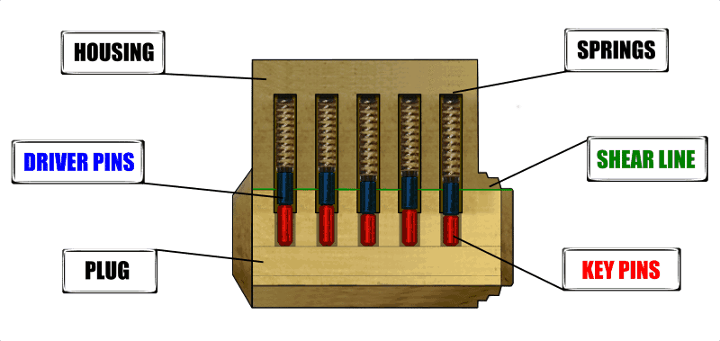

1. **The Housing:** The housing of the lock is essentially a fixed outer shell that holds all the functional parts together.

2. **The Plug:** The plug — or cylinder — is where we insert the key and rotates freely inside the shell when the key is inserted. The plug has a series of holes drilled down the center that allows small pins to enter and exit.

3. **The Shear Line:** The **shear line** is the physical gap between the plug and the housing. As we will see later, the shear line plays one of the most important roles in lock picking.

4. **Driver Pins:** The **driver pins** are the top set of pins and typically sit halfway between the housing and the plug. Because of this, the plug is restricted from rotating freely as any rotational force placed on the plug would result in binding the driver pins.  These pins are the meat and bones of the lock and are what keep the lock… well locked.

5. **Key Pins:** The**key pins** are the bottom set of pins and do exactly as the name suggests, make contact with the key when inserted. Each key pin is a different length to match the bitting — or cut — of the appropriate key. We will see the significance of this in a moment.

6. **Springs:** The springs do what springs do best, push stuff. Their purpose in the lock is to force the driver pins into the plug, thus keeping the plug from freely rotating.

When the key is placed into the cylinder, it pushes the key pins flush with the shear line causing the driver pins to exit the plug. When the gap between the key pins and driver pins is exactly that of the shear line we can rotate the plug and disengage the lock.



This is the basis of pin and tumbler lock picking, to mimic the key by bumping every pin flush with the shear line and then rotating the plug. But why is it that we can do this in the first place and how is it that we can keep every pin at the shear line without the constant pressure of a key? The answer is simply “flaws.”

**Flaws Are Good: Manufacturing Tolerances**

Nothing is perfect. Nothing can be produced without its flaws or some variation from its ideal design. Everything is designed with a tolerance in mind.

It is because of these flaws in production that we are able to manipulate and bypass locks. In the case of the tumbler lock, we have only but to look at the plug.

During the production of the plug, holes are drilled to hold the key pins. Ideally, these holes would all run down the true center-line of the plug and would be in perfect alignment with each other hole. But again nothing is perfect. Each hole drilled has some variation from both the true center-line and from each other hole.

The quality of the lock greatly depends upon the quality and care that is put into drilling these holes. Cheaper locks will generally have a greater variation between holes than that of higher quality locks.

In any case, this variation can be as slight as a thousandth of an inch, however, it’s because of this tiny distortion that we gain our ability to pick locks.

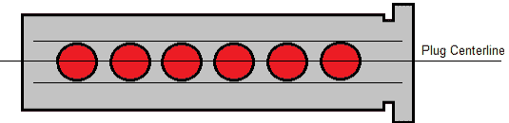

Perfectly produced lock plug. All pin holes run perfectly down the center line of the plug

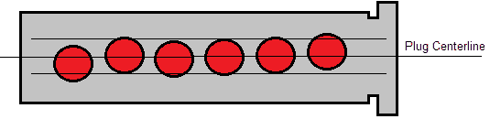

An exaggerated example of a real lock plug. All pin holes vary in distance from the true center-line of the plug.

There is an important term that lock pickers refer to as the “**binding pin.**” This pin is defined as the pin furthest from the plug’s true center-line. If you were to attempt to rotate the plug without the key, the binding pin would be the first in the line of pins to stop the plug from turning.

This [binding pin will become bound between the housing and the plug before any other pin](https://www.art-of-lockpicking.com/what-is-binding-order/). Because of the way the pin holes are drilled into the plug, the binding pin has a slight likelihood of being either the first or last pin in the plug, but regardless of this tendency, it’s still more likely for its location to be completely random.

Before we move on let’s review the two essential concepts required for understanding lock picking.

1. We must raise the pins to the shear line in order to turn the plug and open the lock.
2. Because of manufacturing errors, the pins all hold a different distance from the center-line of the plug. The pin furthest away from the center-line will also be the first pin to bind if the plug is rotated without the key. This pin is called the binding pin.

With an understanding of these two basic concepts, we can, at last, begin to take our first practical steps in learning how to pick a door lock, or any lock for that matter.

**Lock Picking Tools**

The most important part of successfully picking any lock is using the proper tools.

The great thing is you don’t actually need a lot of tools. As a matter in fact, a couple hooks, rakes, and tension wrenches is all you’ll ever need, regardless of skill.

**The Tension Wrench**

The first order of business is learning how to properly use the tension wrench. This little bent piece of metal is used to accomplish two things.

Firstly, it acts similar to the key where it gives us the leverage we need to turn the plug. But more importantly, this tiny wrench is the tool that helps us to keep the pins at the shear line as we pick them.

Here is how it works. As we put slight tension on the wrench, the binding pin will stop the plug from rotating.

It’s here that we can now understand the importance of the binding pin. As the pin begins to bind, we push it up past the shear line with our pick and once up and out, the lock will turn ever so slightly as the plug finds the next binding pin to stop on.

But what also results is if you maintain the correct amount of tension on the wrench, the driver pin will remain out of the plug and above the shear line while the key pin falls back into its hole. While the plug only turns ever so slightly, it is enough for the driver pin to catch on the top of the plug and if the tension is released, the pin will fall back.



So now that we know what we are trying to accomplish inside the lock, let’s get down to it. Take your tension wrench and insert the shorter end into the lower part of the keyhole.

While not always necessary, we sometimes need to determine in which direction the plug turns. To accomplish this apply pressure to the tension wrench clockwise and then counterclockwise. The plug should turn slightly both ways before it stops.

As you rotate the plug both ways, focus on how the tension wrench feels as it stops. If it feels stiff and has little give, this is likely the wrong direction of rotation. Whereas the right direction of rotation will feel mushy and give a little more. Something else to keep in mind is some cheaper locks will open in whichever way you rotate the plug, such as the majority of padlocks.

Once we are aware of which way the plug turns we can begin to put tension on the wrench in that direction.

The amount of tension we exert is key to successfully picking the lock. If we exert too much pressure the pins will bind below the shear line. If we don’t use enough tension the pins will simply fall back into the plug. Developing this feel for the tension wrench is the primary skill involved in lock picking.

A general rule of thumb when using the tension wrench is to use one finger and start with the slightest touch, increasing pressure as you find it necessary. As we apply slight tension on the plug, the binding pin will begin to bind. The next step is to find this pin and push it above the shear line.

**How to Pick a Lock with Single Pin Picking**

So now that we know all this mumbo jumbo we can finally address the task at hand, picking a lock. While there are multiple methods that one can use to pick a lock, we are first going to look at the method called **single pin picking**— also known as SPP.

In this method, we simply bump each individual pin up one at a time using a hook-type pick.

While single pin picking is not the fastest nor easiest method, it is the best in regards to learning how to pick a padlock or door lock as it gives us a better understand of exactly what is going on inside a lock. Obtaining this understanding can be the difference between the mediocre and the master. With that being said, let’s give it a shot.

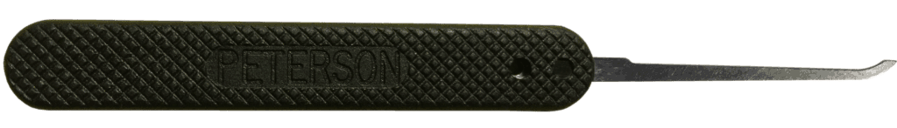

**1. The first thing we have to do is locate the binding pin.**

Insert your tension wrench and give it the necessary pressure to bind the first binding pin. You will need to keep tension on the plug during the entire process of picking the lock.

Next, insert your pick into the top of the lock and, starting from either the front or back, begin to cautiously probe each pin by lifting it up slightly. As you push each pin up, gauge how difficult it is to move.

Most of the pins will be relatively easy to lift with the exception of the binding pin. This pin will feel stiff and if you were to release the tension on the plug it would once again feel like the rest of the pins.

**2. Once we have found the first binding pin we need to raise it above the shear line.**

While continuing to apply light pressure on the tension wrench, begin to gently lift the binding pin. When the pin reaches the shear line there will be a very slight give in the turning of the plug. You may also feel a slight click vibrate through your tension wrench.

**On**

These both are very good indicators that you have successfully “picked” the pin, or what lock pickers refer to as “setting a pin.”

If you were to at this point release tension on the plug, you would hear the pin fall back into place. Note here that you have only lifted the driver pin out of the plug and not the key pin so don’t be alarmed when you still feel it wobbling around inside the plug.

**3. Find the second binding pin**

As a result of setting the first pin, we have removed the first binding pin from interfering with the plug. Because of this, the plug will turn until it hits the next furthest pin from the center-line.

This becomes our new binding pin and our next target. Just like with the first pin, you will need to probe the remaining pins to find the new binding pin. Once found, slowly lift it up past the shear line until you again feel the click and give of the plug and it turns ever so slightly.



**4. Continue to apply pressure on the tension wrench, repeat the same steps of locating the new binding pin and setting it.**

Once all the pins are set, the plug will give and allow us to fully rotate it as if we had a key. That’s all there is to it!

If by chance the pins either don’t set or keep falling, it is likely that you need to re-adjust the amount of pressure that you are applying to the tension wrench. With some practice, you will develop a feel for exactly how much pressure to exert throughout the entire process. Additionally, check out our guide to [honing your single pin picking skills](https://www.art-of-lockpicking.com/single-pin-picking-skills/).

**How to Pick a Lock with Raking**

One of the easiest ways to pick a lock is called raking. Raking has currently become the most common method for lock pickers as it’s quicker and the easiest way to pick a lock.

Raking is accomplished by inserting your pick into the back of the lock and quickly pulling it across the pins repeatedly with an upward force while at the same time applying tension on the plug. This will cause the pins to bounce up above the shear line.

While it works for most cylindrical tumbler locks, this method will struggle if the pins have any dramatic changes in size. An example of this would be as follows: one short pin – one long pin – one short pin – one long pin.

While raking can be accomplished with just about any type of pick, it is most commonly and more efficiently done with a rake-type of pick. These picks commonly have a wavy edge but can also include picks such as the diamond or ball pick.

Although there are many variations of each type of pick, a basic example of each can be seen below.

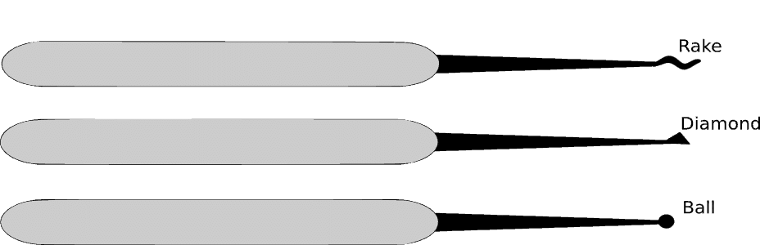

Similar to single pin picking, the success we have in raking depends vastly on the use of the tension wrench. Too much tension will cause the pins to bind below the shear line, while with too little tension the pins will again fall back into place. With that being rehashed, let’s get raking.

Just as before insert the tension wrench into the bottom of the keyhole and apply slight tension to the plug. Now insert your pick into the back of the lock while applying an upward pressure on the pins. Gently snap the pick out in a scrubbing sort of motion being sure to bump all the pins on your way out.

Repeat this three or four times until all of the pins are set and the plug turns. If the lock does not unlock within five rakes, release the tension on the plug and carefully listen for any set pins to dropIf you do not hear any pins drop back into place this means you were either using too much tension or not enough. Adjust the tension either lighter or heavier and try raking the lock again. Continue doing this until all the pins set and the plug turns.

With practice, you will gain a feel for the appropriate amount of tension to place on the plug as you rake and will soon be able to open a lock within your first couple attempts. If raking doesn’t seem to be working on a particular lock, it can still be used to set several pins and you can finish off the lock with the single pin picking method.